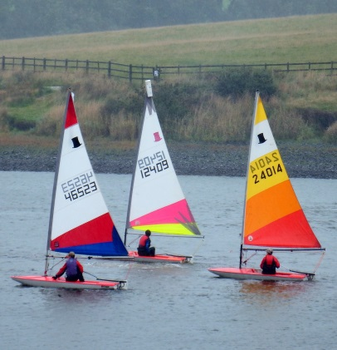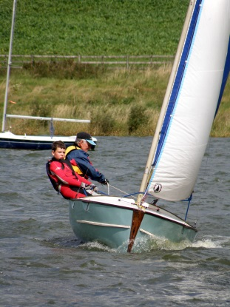

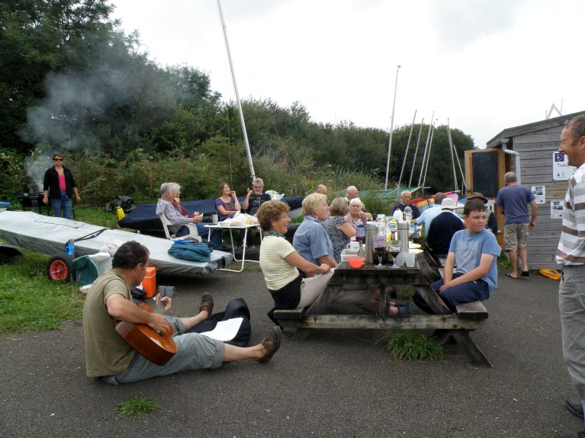

Website and Facebook: We have an useful web site with all the information you will need:
www.utlsc.org.uk. Once you are a club member, you can join the club’s Facebook group, where you can find out about crewing opportunities .

Upper Tamar Lake Sailing Club
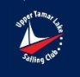

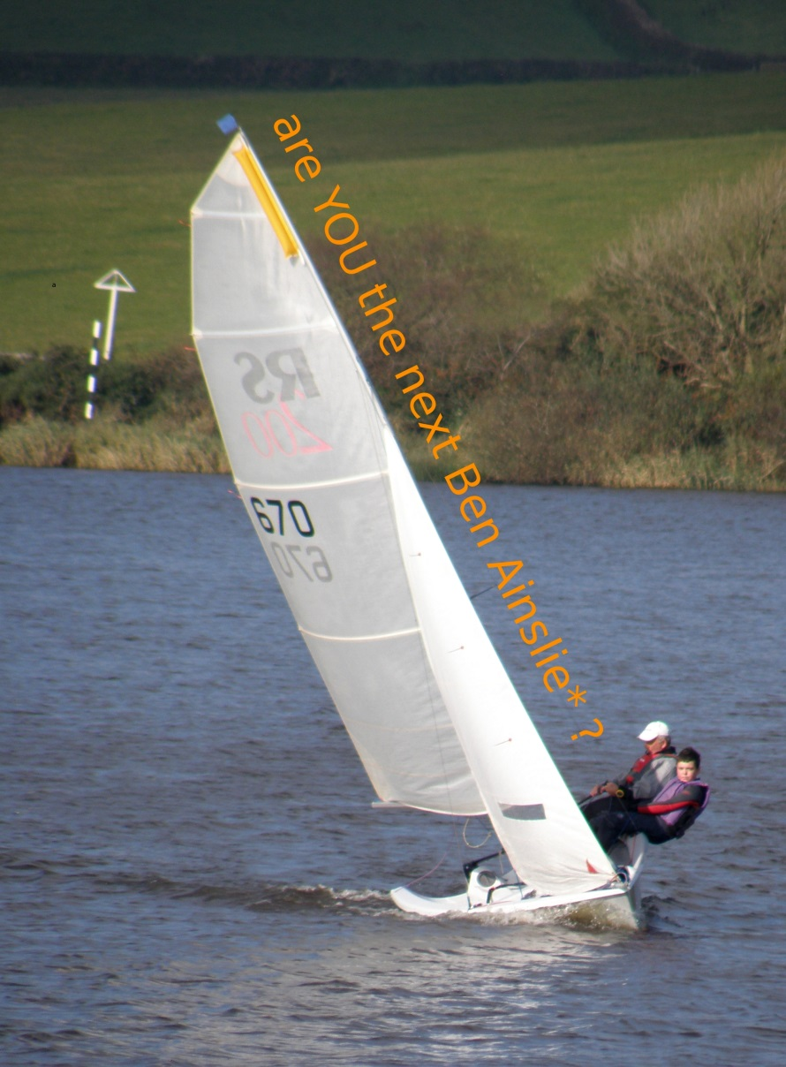

We especially welcome young people to our club. Younger members often join us through a member of their family or through friends, from the South West Lakes Trust (SWLT) Saturday Club
Here are a few pointers to help you when you first join us:

1. Club membership to under-18s is free for the first year. Buoyancy aids, wet suits and safety helmets are available to borrow at no extra cost from SWLT based at the Water Sports Centre beside the lake.

2. Crewing: The best way to start sailing with us is to crew for someone who knows how to sail in one of the two-handed boats so that you get to learn about the club, meet other sailors and learn about racing rules and the buoys on the lake. When you crew you will be expected to help rig and launch the boat as well as help de-rig at the close of sailing – all good learning! When club boats are used you are asked to contribute a small sum towards boat upkeep to be arranged on the day.
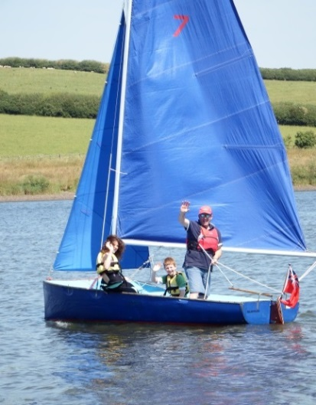
3. Helming: If you are a competent sailor, we have two Topper dinghies you can use for a small contribution payment. You do however need to pay launching or membership fees to SWLT when you helm a boat. All sailors need to be aware of other people using the lake, especially fishermen with tackle, and keep 30 metres away from them on the lake.

4. Sunday racing from March to November: The morning race starts at 12 noon. People arrive at the lake 10.30 am onwards to change and rig their boats. We bring our own picnic lunch to eat between races. The second race starts at 2.30 pm (2 pm at beginning and ending weeks of the sailing season). Juniors can race with the adults and gain points towards the trophies. We also run a series of races with a trophy just for junior sailors called the Junior Helm.

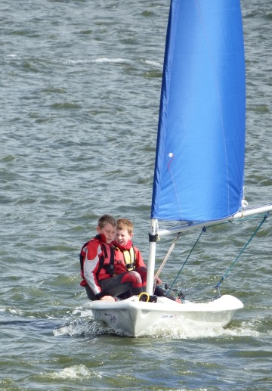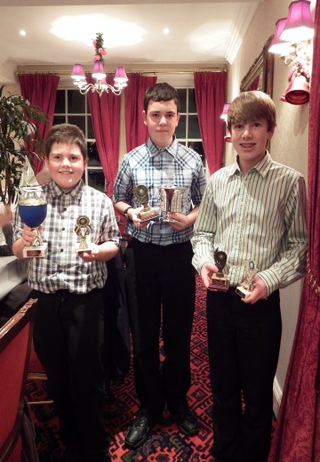
5. Family social activities:
We organise monthly social activities for example: steam train rides, bike rides, river cruises and ten pin bowling.
We have a designated Child Welfare Officer whose contact address is on the website and club noticeboard.

Welcome and enjoy sailing with us!

